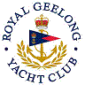 | Royal Geelong Yacht Club Inc.  Est 1859
Trophy Deed of Gift.

Trophy: | Elaine Markby Perpetual Trophy
Presented by:
Date: | 1975
For: | Winner of Corio bay Heat of the Geelong Advertiser Trophy
Remarks / Revisions | Silver Bucket

